Dear ANCW and Collegiate Beef Advocate Supporter:

We are excited to announce that the 2023-24 Collegiate Beef Advocacy Program Advocates is launching our sponsorship campaign! Developing beef advocates and leaders for the cattle industry is the goal of the Collegiate Beef Advocacy Program (CBAP). Hosted by American National Cattlewomen (ANCW) the program provides an outlet for students to use their unique strengths to connect with peers to promote beef. This experience will further participants' passion for beef advocacy by providing top notch training, access to educational resources and unique experiences.

Our goal is to raise funds for travel/flights, transportation, registration fees, apparel, training seminars, and whatever else comes up during this advocacy year, that will ease/reduce the burden of cost for these talented beef advocates.

Every category listed above comes with different costs which adding up can be a large factor weighing potential advocates' decisions on applying or not to our program. With your monetary donation then we hope to lift financial burdens and expand our program to teach young advocates the importance of the beef industry. An example of what your donation would go towards could include but is not limited to a plane ticket to take an advocate to a learning summit in Washington D.C. where they are learning from NCBA frontliners about the laws that affect everyday beef production or land preservation. The donation can also be used during their visit to allow them to wear official business name tags or allow the advocates to ride in ground transportation from meeting to meeting. Every donation will be used to help shape this next generation of cattle producers.

What would you receive from donating to the Collegiate Beef Advocacy Program? We would love to promote our sponsors on our social media platforms, with promotion posts about what you do for the beef industry. Another option would be printing your logos out and placing it on pieces that our advocates use throughout their time in the program. This could include and is not limited to your business’s logo on a sticker on a suitcase or water bottle.

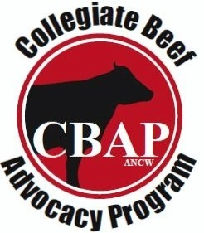
We greatly appreciate your contribution in allowing us the opportunity to advance a highly educational program in the beef industry.

Below are the options for sponsorships or donations option:
(Suggested amount ranges which are not limited)
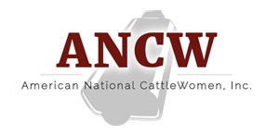
Transportation - $25+
CBAP Merch - $50+
Meals for a Day - $100+
Flight(s) - $300+
Event Registration Fee - $500+
Additional Sponsorship - Any given amount

Sponsor Information

Business Name: ______________________________________________________________

Contact Name: ________________________________________________________________

Contact Number: ______________________________________________________________

Contact email: ________________________________________________________________

Business/Contact Address: ______________________________________________________

Amount/Package: _____________________________________________________________

Options for payment:
- Online at: https://ancw.org/CBAP-Sponsorship
- Mail check to:
  - ANCW
PO Box 700038
Saint Cloud, FL 34770

Thank you in advance for donating to the ANCW Collegiate Beef Advocacy Program!

Committee Directors:

Program Email Contact: ancw.cbap@gmail.com

Nikki Weston 208-847-5243 nikkiweston0@gmail.com

Katie Kixmiller 812-890-2041 katiekix5@outlook.com

Ashley Evans 775-980-5605 ashley.huntsberger@gmail.com

