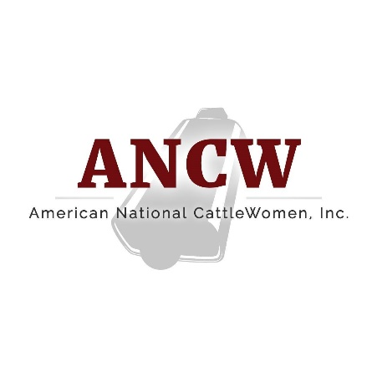

American National CattleWomen
16799 Prairie Circle · El Reno, OK · 73036
February 7, 2022
For more information:
Cheyenne Sparks, ancw@ancw.org

Reba Mazak named President of the American National CattleWomen
HOUSTON – Florida CattleWoman, Reba Mazak has been named the American National CattleWomen (ANCW) President. Mazak, of Sumter County, FL., was named to the position at the 2022 Cattle Industry Convention in Houston, Jan. 31, 2022. Over the next year, Mazak will lead the initiatives of the ANCW along with fellow officers President-Elect Pamela Griffin of Arizona and Vice President Ruth Coffey of Oklahoma as she encourages cattlewomen across the country to “Git Up In ANCW”.
Mazak is a fifth generation Florida cattle rancher. She grew up on a ranch in Geneva, Florida and later moved to Sumter County, Florida where she resides today. She married her late husband, Paul Mazak, when she was eighteen years old. Together, Paul and Reba started and grew their own cattle operation. She owns approximately 300 commercial cow/calf pairs spread between her ranch in Sumter County, Florida and Uvalde, Texas. Aside from the cattle operation, Mazak owns a limerock mine in Central Florida and a manages a hunting program in Southwest Texas.

Mazak has been a part of the Florida CattleWomen, formerly known as the Cowbelles for more than 40 years. She has held all offices at the state level and served as state President in 2004, where she spoke to the United States Senate Committee on Agriculture, Nutrition and Forestry about the Beef Check Off. She currently serves on the Florida CattleWomen Convention Committee.

Mazak served on the Silent Action Committee, the Ways and Means Committee and the Executive Board for American National CattleWomen. She has also completed the Masters of Beef Advocacy Program, was a part of the first class to graduate from ANCW Women’s Leadership Program in 2018 and is BQA certified.

In her spare time, Mazak enjoys spending time with her two daughters and their spouses, Rebecca and Grant Handley and Audra and Wes Platt, and her four grandsons Mayland, Myles, Warren and Waylon. She enjoys ranching and promoting the beef industry.

###
American National CattleWomen is a voice for women who share a passion for the beef community with focus areas in beef promotion, education and legislation. For more information, visit www.ancw.org.

