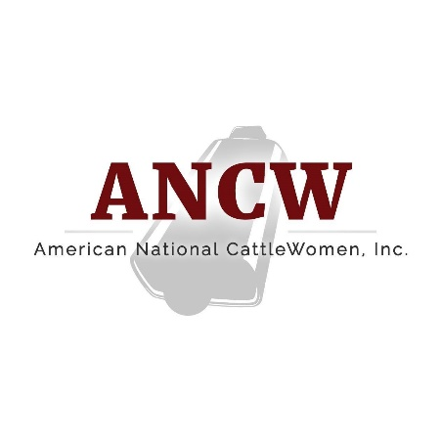

American National CattleWomen
16799 Prairie Circle · El Reno, OK · 73036
February 7, 2022
For more information:
Cheyenne Sparks, ancw@ancw.org

Ruth Coffey named Vice President of the American National CattleWomen
HOUSTON – Oklahoma CattleWoman, Ruth Coffey has been named the American National CattleWomen (ANCW) Vice President. Coffey, of Spring, OK., was named to the position at the 2022 Cattle Industry Convention in Houston, Jan. 31, 2022. Over the next year, Coffey will support the initiatives of the ANCW along with fellow officers President Reba Mazak of Florida and President-Elect Pamela Griffin of Arizona.
Coffey, along with husband, Chuck, and their children run the Double C Cattle Company in south central Oklahoma, a fifth-generation cow calf operation. In 2019, the Coffeys were awarded the Oklahoma Leopold Conservation Award and in 2020 they were the recipients of the National Cattlemen’s Beef Association Environmental Stewardship Award Program (ESAP). ESAP strives to recognize “outstanding stewardship practices and conservation achievements of U.S. cattle producers”. Both Ruth and Chuck have been active in the cattle industry for many years.
Prior to this position, Coffey served in the role of ANCW Region IV Director from 2020-2022 and served as a member on the ANCW Membership and Communications Committee. She was also named the ANCW Promoter of the Year in 2020, Oklahoma CattleWoman of the Year in 2019 and served as the OCW President from 2017-2019.
Her love for education began in her college years as she obtained a degree in Elementary Education and Art at Trinity University in San Antonio, TX. Upon graduation, Coffey owned and operated a custom framing studio in Tishomingo, OK and would go on to teach middle school art for over 15 years. Coffey would return to school to study Rangeland Ecology and Management at Texas A&M University. She retired from teaching to focus on her family ranch and now devotes her time to supporting the beef community on a local, state and national level.
Coffey enjoys time spent outdoors with her horses and grandchildren. She is most looking forward to learning about the ways in which her fellow CattleWomen raise cattle in their regions and getting to study the different sectors of the U.S. cattle industry.
###
American National CattleWomen is a voice for women who share a passion for the beef community with focus areas in beef promotion, education and legislation. For more information, visit www.ancw.org.

